**Exercise 1: Control Structures**

**Tables:**

CREATE TABLE Customers (

CustomerID int PRIMARY KEY,

Name VARCHAR(10),

Age int,

Balance int,

IsVIP VARCHAR(5) DEFAULT 'FALSE'

);

CREATE TABLE Loans (

LoanID int PRIMARY KEY,

CustomerID int,

InterestRate int,

DueInDays int, -- Simple numeric instead of DATE

FOREIGN KEY (CustomerID) REFERENCES Customers(CustomerID)

);

INSERT INTO Customers VALUES (1, 'Alice', 65, 12000, 'FALSE');

INSERT INTO Customers VALUES (2, 'Bob', 45, 8000, 'FALSE');

INSERT INTO Customers VALUES (3, 'Charlie', 70, 11000, 'FALSE');

INSERT INTO Customers VALUES (4, 'David', 30, 9500, 'FALSE');

INSERT INTO Loans VALUES (101, 1, 10.5, 10); -- Due in 10 days

INSERT INTO Loans VALUES (102, 2, 12.0, 40); -- Due in 40 days

INSERT INTO Loans VALUES (103, 3, 9.0, 25); -- Due in 25 days

INSERT INTO Loans VALUES (104, 4, 11.0, 5); -- Due in 5 days

Select * from Customers;

select * from Loans;

**Initial Tables:**

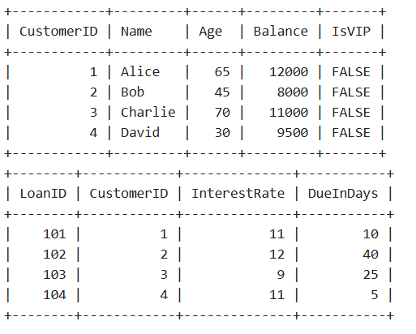

**Scenario 1**: The bank wants to apply a discount to loan interest rates for customers above 60 years old.

* + Question: Write a PL/SQL block that loops through all customers, checks their age, and if they are above 60, apply a 1% discount to their current loan interest rates.

**Answer:**  
BEGIN  
 FOR cust IN (SELECT CustomerID, Age FROM Customers) LOOP  
 IF cust.Age > 60 THEN  
 UPDATE Loans  
 SET InterestRate = InterestRate - 1  
 WHERE CustomerID = cust.CustomerID;  
 END IF;  
 END LOOP;  
 COMMIT;  
END;  
  
**output(tables after the scenario 1):**

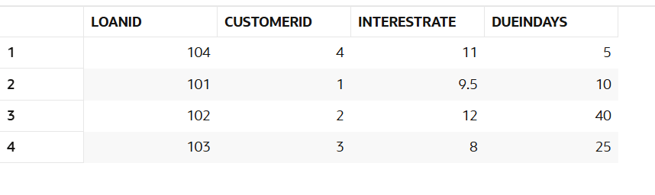

**Scenario 2:** A customer can be promoted to VIP status based on their balance.

* + **Question:** Write a PL/SQL block that iterates through all customers and sets a flag IsVIP to TRUE for those with a balance over $10,000.

**Answer:**  
BEGIN  
 FOR cust IN (SELECT CustomerID, Balance FROM Customers) LOOP  
 IF cust.Balance > 10000 THEN  
 UPDATE Customers  
 SET IsVIP = 'TRUE'  
 WHERE CustomerID = cust.CustomerID;  
 END IF;  
 END LOOP;  
 COMMIT;  
END;

**output(tables after the scenario 2):**

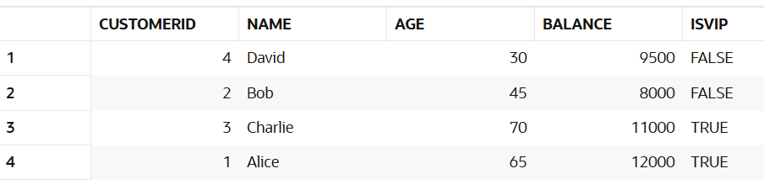

**Scenario 3:** The bank wants to send reminders to customers whose loans are due within the next 30 days.

* + **Question:** Write a PL/SQL block that fetches all loans due in the next 30 days and prints a reminder message for each customer.

**Answer:**  
BEGIN  
 FOR loan IN (SELECT LoanID, CustomerID, DueDate FROM Loans   
 WHERE DueDate <= SYSDATE + 30) LOOP  
 DBMS_OUTPUT.PUT_LINE('Reminder: Loan ' || loan.LoanID ||   
 ' for Customer ' || loan.CustomerID ||   
 ' is due on ' || TO_CHAR(loan.DueDate, 'DD-MON-YYYY'));  
 END LOOP;  
END;

**Output:**

